Name____________________________________________________Class_________
Art Reflection- Haiku
Artwork Title:_____________________________________________________
Artist:__________________________________Date _____________________
List 5 things you see in this artwork:
List 5 nouns (things you see): | List 5 verbs (action words) that describe what’s happening in the art:
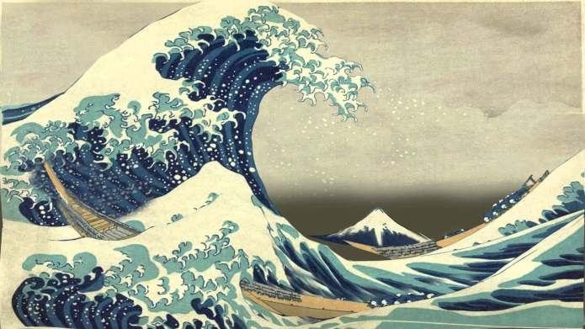
List 5 adjectives that describe the artwork:

Write a haiku poem about the artwork using some of the words above
Title_____________________________
Line 1:_______________________________________ (5 syllables)
Line 2:_______________________________________________(7 syllables)
Line 3:_______________________________________ (5 syllables)

Haiku examples: (You may not copy these, but these will show you how the syllables work)

Rainstorm
Crashing thunder sound
While the sky drops in contents
After, a rainbow

Daughter
Tiny burst of light
Joy erupts like solar flare
You are my sunshine

