Map of the
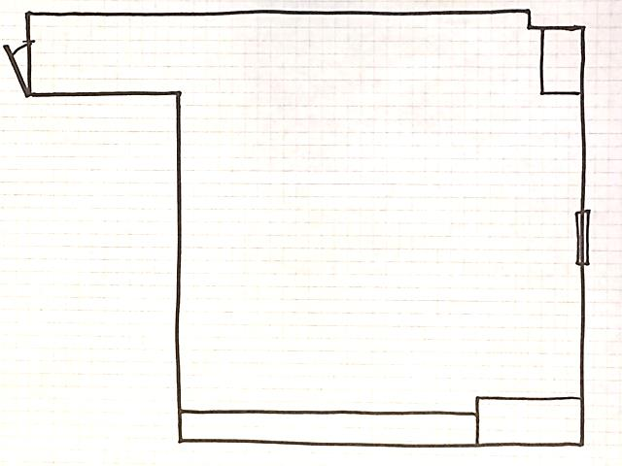
Art Room

Art Room Scavenger Hunt
1.____________________________
2.____________________________
3.____________________________
4.____________________________
5.____________________________
6.____________________________
7.____________________________
8.____________________________
9.____________________________
10.___________________________

